Clеrk SRS

generated by Clerq on November 8, 2019 at 20:51 using ‘pandoc.md.erb’ template

Table of Contents

# 1 Introduction

## 1.1 Purpose

The purpose of this document is to provide a demo project “Clerq Promo SRS” for all perspective Clerq users to introduce the system by example and provide a sandbox for experiments for the existing users.

The other purpose (rather technical) is to have repository that provides all possible combinations of markup inside (links, ids, macros, etc.) to exercise in writing documents templates.

## 1.2 Scope

This software system will be a command-line interface (CLI) that provides a set of tools related to requirements management tasks. The system will also provide the requirements repository structure and the format of the requirements sources.

The system does not provide any graphical user interface. Assumed that users create and write requirements through any available text editor application, and manage requirements repository structure through any available file manager application.

Any features related to restricting access to the requirements repository or to the functions of the system are out of scope. Assumed that each project repository is under control of an SCM tool (Git, Subversion, etc.) and the SCM is in charge of user’s access to the SCM artifacts.

## 1.3 Definitions, acronyms, and abbreviations

CLI

Command-line interface

VCS

Version control system

SCM

Software configuration management

User story

User stories at [www.agilealliance.org](https://www.agilealliance.org/glossary/user-stories)

OS

Operations System

## 1.4 References

1. [Markdown Guide](https://www.markdownguide.org/)
2. [Pandoc User’s Guide](https://pandoc.org/MANUAL.html)
3. [Git Documentation](https://git-scm.com/doc)

## 1.5 Overview

The remaining sections of this document provide user requirements and functional requirements of the system.

The next chapter 2 User stories introduces the system from User Stories’ point of view and establishes the context for the functional requirements. The chapter is organized by user roles.

The following chapter 3 Functional requirements describes detailed requirements for functions and user interfaces that are based on user stories from the previous chapter. The chapter is structured around system components and is written primarily for developers and quality assurance specialists.

# 2 User stories

## Reader

|  |  |
| --- | --- |
| Attribute | Value |
| id | us.reader |

A requirements reader uses requirements in his day to day work as an input for other project activities or participates in the requirements review process.

### Chose a presentation format

|  |  |
| --- | --- |
| Attribute | Value |
| id | us.reader.01 |

As a reader, I want to get requirements in a particular document format (PDF, Html, MS Word, OpenDocument, etc.), so that I can use my usual tools to work with the document.

## Writer

|  |  |
| --- | --- |
| Attribute | Value |
| id | us.writer |

A requirements writer / author / developer / analyst

### README, HOW-TO

|  |  |
| --- | --- |
| Attribute | Value |
| id | us.writer.01 |

As a requirements analyst who visits the project promo page, I want to get some introduction to the project and its features, so that I understand how close it meets my needs.

### Write in plain text files

|  |  |
| --- | --- |
| Attribute | Value |
| id | us.writer.02 |

As a requirements writer, I want to develop and store requirements in plain text, so that my readers and I would not need to install any specialized software to work with requirements.

### Using of lightweight markup language

|  |  |
| --- | --- |
| Attribute | Value |
| id | us.writer.03 |

As a requirements writer, when I work on the requirements text, I want to use a lightweight markup language (LML), so that it still plain text and, at the same time, I have basic formatting capabilities of style and structure of a text, lists, and tables.

### Set of separate files

|  |  |
| --- | --- |
| Attribute | Value |
| id | us.writer.04 |

As a requirements writer, when I develop requirements, I want to structure the entire set of requirements as a set of separate files and folders, so that I have a high degree of agility but some drawbacks also …

* I can write different complex topics in different files and folders;
* I can share the same repository with other authors without problems like the necessity to work with the same file simultaneously more that one person:

### Requirements subordination and order

|  |  |
| --- | --- |
| Attribute | Value |
| id | us.writer.05 |

As a drawback for the previous story when I have requirements in separated files, I need an ability to specify requirements subordination and output order through separated files, so that I can combine all requirements into the consistent repository.

### Supporting Metadata

|  |  |
| --- | --- |
| Attribute | Value |
| id | us.writer.06 |

As a requirements writer, when I develop requirements, I want to mark requirements text by some metadata (source, author, dependencies, etc.), so that I can use the metadata for tagging, searching, selection, referring, etc.

### Supporting Links

|  |  |
| --- | --- |
| Attribute | Value |
| id | us.writer.07 |

As a requirements writer, when I develop requirements, I want to link those with each other through simple references, so that I refer from one requirement to others.

### Requirements templates

|  |  |
| --- | --- |
| Attribute | Value |
| id | us.writer.08 |

As a requirements writer, when I develop requirements, I want to create and use requirements templates, so that I simplify my work, improve productivity and provide basic writing style.

### Checking repository

|  |  |
| --- | --- |
| Attribute | Value |
| id | us.writer.09 |
| topic | true |

As a requirements writer, I want to check requirements repository for different possible errors, so that I fix the errors and have consistent repository.

Manual files writing and writing in separate files especially can cause the following errors:

* Errors in structure of a requirements file;
* Errors in linking or ordering requirements;
* References that not exist in the repository;
* Duplicates of requirements identifiers.

### Querying requirements

|  |  |
| --- | --- |
| Attribute | Value |
| id | us.writer.10 |

As a requirements writer, at any time, I want to query requirements (based on its attributes such “id”, “title”, “body”, and metadata), so that I can have different subsets of requirements based on my needs.

### Combining into documents

|  |  |
| --- | --- |
| Attribute | Value |
| id | us.writer.11 |

As a requirements writer, at any time, I want to combine requirements to a single consistent requirements specification, so that I can have requirements draft and releases.

### Providing unique identifiers

|  |  |
| --- | --- |
| Attribute | Value |
| id | us.writer.12 |

As a requirements writer, I want to have automatically created unique identifiers for the requirements where it omitted, so that I will always have unique identifiers for all requirements.

### Document templates

|  |  |
| --- | --- |
| Attribute | Value |
| id | us.writer.13 |

As a requirement writer, I want the system support ability to chose different templates for documents, so that I can have templates for different purposes (drafts and releases) and even software products (GitHub Markdown, Gitlab Markdown, Pandoc Markdown to convert to docx, odt, or pdf.)

### Create own document template

|  |  |
| --- | --- |
| Attribute | Value |
| id | us.writer.14 |

As a requirements writer, I want to have ability to create my own templates or modify existing templates, so than I can do template tuning for my needs.

### Script automation

|  |  |
| --- | --- |
| Attribute | Value |
| id | us.writer.15 |

As a requirements analyst, I want have ability to automate my working tasks related to requirements, so that I can write scripts related to publishing, reviewing or deriving other artifacts based on the requirements (backlog, estimation sheet, traceability matrix, etc.).

# 3 Functional requirements

## Components

|  |  |
| --- | --- |
| Attribute | Value |
| id | cmp |

The system shall provide the following components:

* Node
* Repository
* Templates manager
* Writer

### Node

|  |  |
| --- | --- |
| Attribute | Value |
| id | cmp.node |

The system shall provide the Node component that represents one single node of a document. The component shall provide the following function:

* Read node from markup text
* Write node to markup text

#### Read node from markup text

|  |  |
| --- | --- |
| Attribute | Value |
| id | cmp.node.read |

The system shall provide the ability to read node from lightweight markup language (markdown) to Node entity.

#### Write node to markup text

|  |  |
| --- | --- |
| Attribute | Value |
| id | cmp.node.write |

The system shall provide the ability to write node from Node entity to lightweight markup language (markdown).

### Repository

|  |  |
| --- | --- |
| Attribute | Value |
| id | cmp.repo |

#### Read repository

|  |  |
| --- | --- |
| Attribute | Value |
| id | cmp.repo.read |

The system shall provide the function to read repository from separate files and folders and combine it to Node entity under root document node.

#### Query repository

|  |  |
| --- | --- |
| Attribute | Value |
| id | cmp.repo.query |

The system shall provide the function to query repository by providing a query string

### Templates manager

|  |  |
| --- | --- |
| Attribute | Value |
| id | cmp.tt |

The system shall provide Template manager component. The component shall provide the following functions:

* Find template

#### Find template

|  |  |
| --- | --- |
| Attribute | Value |
| id | cmp.tt.find |

The system shall provide function find for templates

**Input**

|  |  |  |  |
| --- | --- | --- | --- |
| Parameter | Type | Required | Description |
| id | String | Yes | Template identifier |

**Output**

Template body (see Template entity) by provided template id parameter.

### Writer

|  |  |
| --- | --- |
| Attribute | Value |
| id | cmp.writer |

The system shall provide the Writer component. The component shall provide functions of writing requirements repository to markup text.

#### Write function

|  |  |
| --- | --- |
| Attribute | Value |
| id | cmp.writer.write |

The Writer component shall provide the function write.

**Input**

|  |  |  |  |
| --- | --- | --- | --- |
| Parameter | Type | Required | Description |
| node | Node | Yes | see Node entity |
| template | Template | Yes | se Template entity |

**Output**

Text presentation of node parameter according to template parameter

## Entities

|  |  |
| --- | --- |
| Attribute | Value |
| id | ent |

### Node entity

|  |  |
| --- | --- |
| Attribute | Value |
| id | ent.node |

The system shall provide Node entity that provide the following attributes:

|  |  |  |  |  |
| --- | --- | --- | --- | --- |
| Attribute | Type | Required | Default | Description |
| id | String | Yes | "" | Node identifier |
| title | String | Yes | "" | Node title |
| meta | Hash | Yes | {} | Node metadata |
| body | String | Yes | "" | Node body |
| items | Array | Yes |  | Array of child nodes |

#### System node options

|  |  |
| --- | --- |
| Attribute | Value |
| id | ent.node.01 |

The system through node metadata shall provide the following system options:

|  |  |  |
| --- | --- | --- |
| Option | Example | Description |
| parent | parent: fr | specifies the node parent |
| skip_meta | skip_meta: true | force the system to skip printing metadata |
| order_index | order_index: .1 .2 | force the system to use specified order for child nodes |

### Template entity

|  |  |
| --- | --- |
| Attribute | Value |
| id | ent.tt |

The system shall provide Template entity that provide the following attributes:

|  |  |  |  |  |
| --- | --- | --- | --- | --- |
| Attribute | Type | Required | Default | Description |
| id | String | Yes | "" | Template identifier |
| body | String | Yes | "" | Template body |

## User Interface

|  |  |
| --- | --- |
| Attribute | Value |
| id | ui |

### CLI

|  |  |
| --- | --- |
| Attribute | Value |
| id | cli |

The following requirements assumed that all CLI commands have to be called in a directory that contains a certain clerq project.

The system shall provide the following CLI commands:

* Project settings
* Getting version
* Help
* Creating new project
* Checking project
* Building project

#### Project settings

|  |  |
| --- | --- |
| Attribute | Value |
| id | cli.opt |

The system shall provide settings file for clerq project. It should be placed under root clerq project directory and called clerq.yml.

Clerq project setting file shall provide the following options:

* document, string, required, represent file name of output document by default;
* template, string, required, represent template of output document by default;
* title, string, required, represent title of the output document;
* author, string, optional, represent optional document author.

#### Getting version

|  |  |
| --- | --- |
| Attribute | Value |
| id | cli.ver |

The system shall provide command clerq --version. When the user requests the command the system shall print its version.

#### Help

|  |  |
| --- | --- |
| Attribute | Value |
| id | cli.hlp |

The system shall provide command clerq help. When the user requests the command, the system shall print the list of all clerq CLI commands with a short description of each command.

##### Input parameters

|  |  |
| --- | --- |
| Attribute | Value |
| id | cli.hlp.par |

The command shall provide the following input parameters:

* COMMAND, string, optional, represent name for the command.

##### 

|  |  |
| --- | --- |
| Attribute | Value |
| id | cli.hlp.01 |

When the COMMAND parameter is provided, the system shall print the detailed description of the command with all supported parameters and options.

#### Creating new project

|  |  |
| --- | --- |
| Attribute | Value |
| id | cli.new |

The system shall provide command clerq new. When the user requests the command the system shall create a new clerq project according to input parameters.

##### Input parameters

|  |  |
| --- | --- |
| Attribute | Value |
| id | cli.new.par |

The command shall provide the following input parameters:

* PROJECT, string, required, represent the name of the new project.

##### 

|  |  |
| --- | --- |
| Attribute | Value |
| id | cli.new.01 |

When parameter PROJECT not provided, the system shall stop the command execution and print the error message Parameter "PROJECT" required!.

##### 

|  |  |
| --- | --- |
| Attribute | Value |
| id | cli.new.02 |

When parameter PROJECT provided and a directory called according to the parameter value exists, the system shall stop the command execution and print the error message Directory "PROJECT" exists!.

#### Checking project

|  |  |
| --- | --- |
| Attribute | Value |
| id | cli.chk |

The system shall provide command clerq check. When the user requests the command the system shall check the clerq repository for errors.

##### 

|  |  |
| --- | --- |
| Attribute | Value |
| id | cli.chk.01 |

When any errors have found during checking, the system shall print the errors grouped by error type. The following errors type shall be checked:

* Non-unique identifiers;
* Unknown/wrong parents;
* Unknown/Wrong links;
* Wrong order_index attribute.

##### 

|  |  |
| --- | --- |
| Attribute | Value |
| id | cli.chk.02 |

When errors have not found, the system shall print the message No errors found. Everything is fine.

#### Building project

|  |  |
| --- | --- |
| Attribute | Value |
| id | cli.bld |

The system shall provide command clerq build. When the user requests the command the system shall combine all requirements in the project repository and build the output document according to input parameters.

##### Input parameters

|  |  |
| --- | --- |
| Attribute | Value |
| id | cli.bld.par |

The command shall provide the following input parameters:

* -o/--output, string, optional, represent name for the output document;
* -t/--template TEMPLATE, string, optional, represent a template for building the document;
* -q/--query QUERY, string, optional, represent query string for requirements.

##### 

|  |  |
| --- | --- |
| Attribute | Value |
| id | cli.bld.01 |

When -o/--output parameter is not provided, the system shall use the default file name from settings of the project.

##### 

|  |  |
| --- | --- |
| Attribute | Value |
| id | cli.bld.02 |

When -o/--output parameter is provided, the system shall save the generated document under the provided name.

##### 

|  |  |
| --- | --- |
| Attribute | Value |
| id | cli.bld.03 |

When -t/--template parameter is not provided, the system shall use the default template from settings of the project.

##### 

|  |  |
| --- | --- |
| Attribute | Value |
| id | cli.bld.04 |

When -t/--template parameter is provided, the system shall check that the provided template exists and use it for document generation.

##### 

|  |  |
| --- | --- |
| Attribute | Value |
| id | cli.bld.05 |

When -q/--query parameter is provided, the system shall check if the provided query is correct query string and select requirements for building the document according to the query.

# Appendix

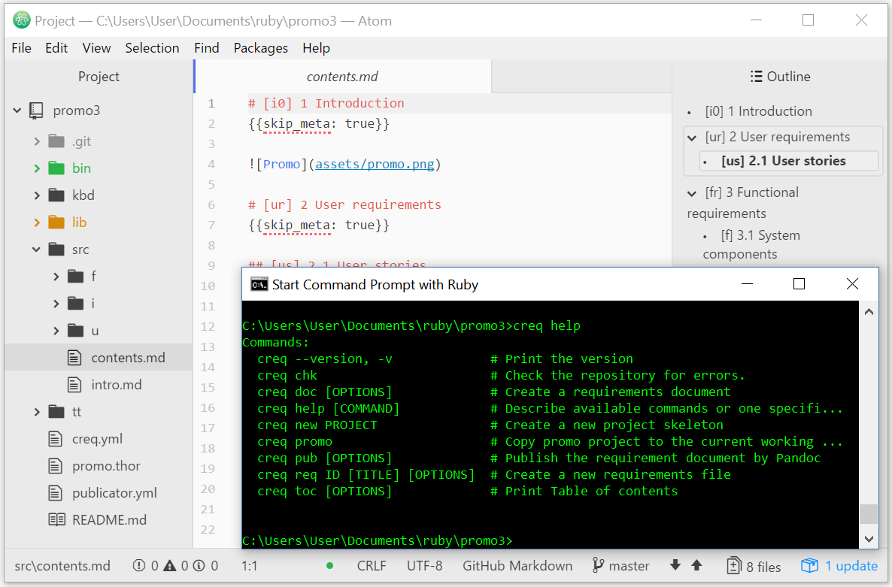

Clerq in Atom